Pre Calc Name: ______________

______________ ______________

WS Assessment

Target 14

Basic trigonometry

* Angles and their measures
* Basic Trig functions and its inverse

HW 14 Basic Trig deltamath.com

A measure of and angle is a number that describes the amount of rotation from the initial side to the terminal side of the angle. Its unit of measurement are degree and radian. Write the formula to convert between them.

|  |  |
| --- | --- |
| Draw a diagram of commonly occurring angles with its unit (degree, radian) on a unit circle  Image result for blank unit circle  Coterminal, Complement and Supplements | Convert degree measure to radian and vice versa  450o -12o rad 7 rad  Convert from DMS to decimal form  83o12’18’’ 19o24’58” |

Find and draw a positive angle and negative angle that are coterminal with the given angle, then find its complement and supplement, or state that none exists

30o -150o rad rad

The radian measure definition $θ=\frac{s}{r}$ is particularly useful for find the length s of an intercepted arc s = r $θ$. This allow us to convert between the vehicle’s linear speed (highway speed) v and the angular speed $ω$ (wheel speed)

The truck has wheels 36 in. in diameter. If the wheels are rotating at 630 rmp. Find the truck’s speed in miles per hour (mph) Ans 67 mph

The wheel (including the tire) of a sport car has a 11 in. radius. What would the car’s speed be if its wheels are turning at 800 rmp.

A radial arm saw has circular cutting blade with a diameter of 10 in. It spins at 2000 rmp. If there are 12 cutting teeth per inch on the cutting blade, how many teeth cross the cutting surface each second?

Evaluating all 6 basic trig function for the following angles (with sketch) in fraction, then check with calculator

30o 45o 60o

Fundamental Trigonometry Identities

Reciprocal Identities $\sin\left(θ\right)=\frac{1}{csc⁡(θ)}$ $\cos\left(θ\right)=\frac{1}{sec⁡(θ)}$ $\tan\left(θ\right)=\frac{1}{cot⁡(θ)}$

Quotient Identities $\tan\left(θ\right)=\frac{sin⁡(θ)}{cos⁡(θ)}$ $\cot\left(θ\right)=\frac{cos⁡(θ)}{sin⁡(θ)}$

Pythagorean Identities $\sin^{2}θ+\cos^{2}θ=1$ $\tan^{2}θ+1=\sec^{2}θ$ $\cot^{2}θ+{1= csc}^{2}θ$

Let $θ$ be an acute angle such that sin( $θ)$ = 5/6. Evaluate the other trig functions.

Suppose angle $θ$ is in standard position with point P(-2, 3) on its terminal side. Evaluate the trigonometry functions for $θ$

|  |  |
| --- | --- |
| Sign of Trig functions (fill in)  Image result for sign of trigonometric functions | State whether the function value is positive or negative. Explain  Sin 210o  Tan  Cos  Sec 125o |

Suppose sin( $θ)$ = 3/7 and tan( $θ)$ < 0. Evaluate cos( $θ)$ and cot($θ)$

Find sin( $θ)$ and tan( $θ)$ if cos( $θ)$ = 2/3 and cot( $θ)$ > 0

Find tan( $θ)$ and sec( $θ)$ if sin( $θ)$ = -2/5 and cos( $θ)$ > 0

The reference angle of an angle $θ$ in standard position is the acute angle formed by the terminal side and the horizontal axis

Find sine, cosine, and tangent using the reference angle. Sketch and check

150o 315o

Properties of the Sine and Cosine Functions

cos $θ$ = cos($θ+2π$) sin $θ$ = sin($θ+2π$) (rotate 1 round more)

cos $(-θ)$ = cos($θ$) (Even function)

sin $(-θ)$ = - sin($θ$) (Odd function)

Solving right triangle

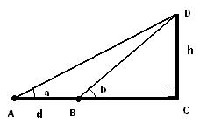From point A, an observer notes that the angle of elevation of the top of a tower (C,D) is ***a*** (degrees) and from point B the angle of elevation is ***b*** (degrees). Points A, B and C (the bottom of the tower) are collinear. The distance between A and B is ***d***. Find the height ***h*** of the tower in terms of d and angles a and b.

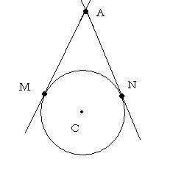

Two lines tangent to a circle at points M and N have a point of intersection A. The size of angle MAN is equal to x degrees and the length of the radius of the circle is equal to r. Find the distance from point A to the center of the circle in terms of x and r.

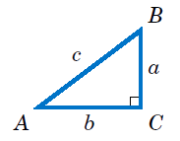For the triangle below, find the unknown if

|  |  |  |
| --- | --- | --- |
| c = 10 A = 22o | b = 8 A = 40o | a = 3 b = 4 |

**Target 14 Assessment**

Find all 6 trig functions of angle $θ$ in the given triangle

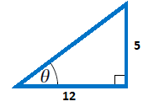

Evaluate all six trig functions of angle 420o. Sketch

Point P (-5, -3) is on the terminal side of angle $θ$. Find all 6 trig functions of angle $θ$. Sketch

Use the fundamental trigonometry identities to evaluate the expression.

tan $θ$ if cos $θ$ = 0.82 tan $θ$ if sin $θ$ = -0.58

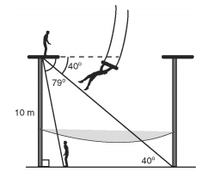Zelda, a trapeze artist, stands on a 10-meter-high platform. He measures a 40° angle of depression to the base of the other platform. Find the distance between the bases of the platforms Zelda’s partner, Zev, is on the ground doing a safety check on the net. Zelda measures a 79° angle of depression to Zev. Find the distance from Zev to the base of Zelda’s platform